**→ Feature based image segmentation using traditional machine learning :**

**(1) Steps for this tutorial :**

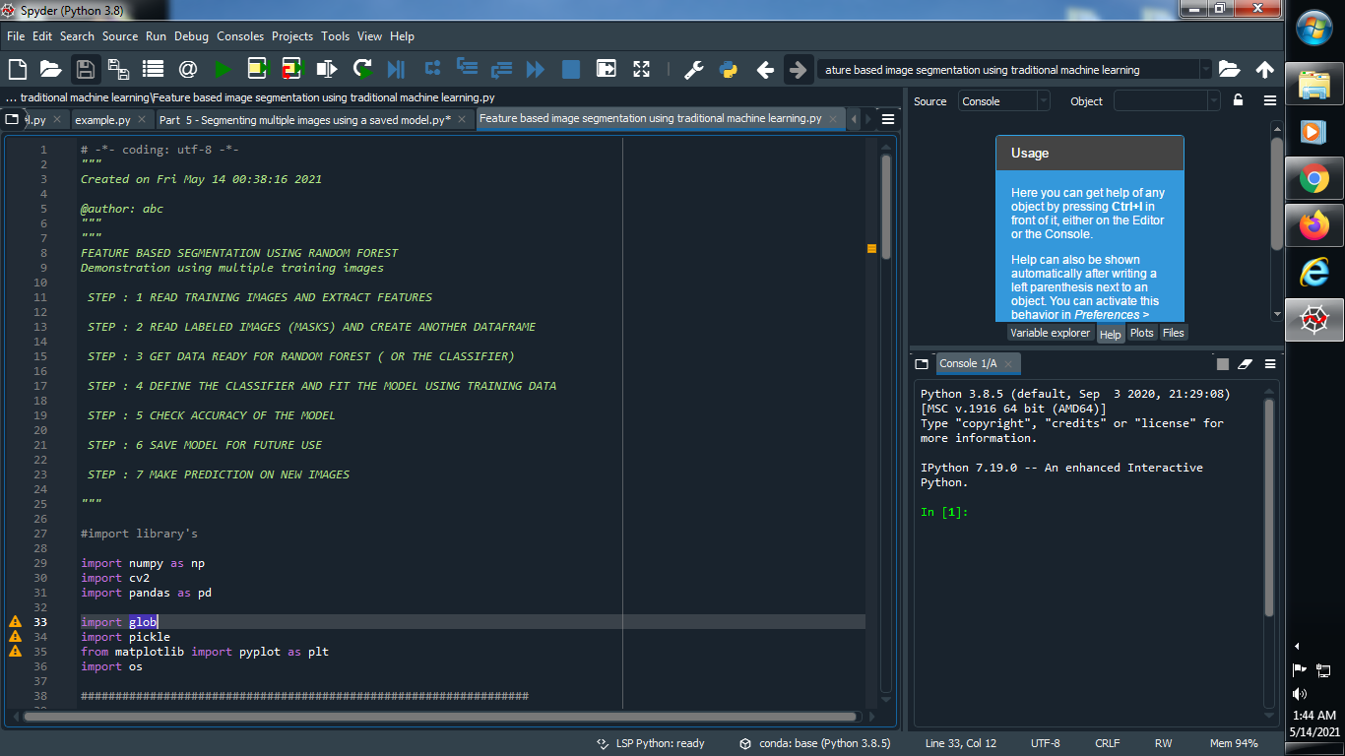

**####################################################################################################################**

**(1) Step : 1 READ TRAINING IMAGES AND EXTRACT FEATURES :**

**→ Let’s import some library’s :**

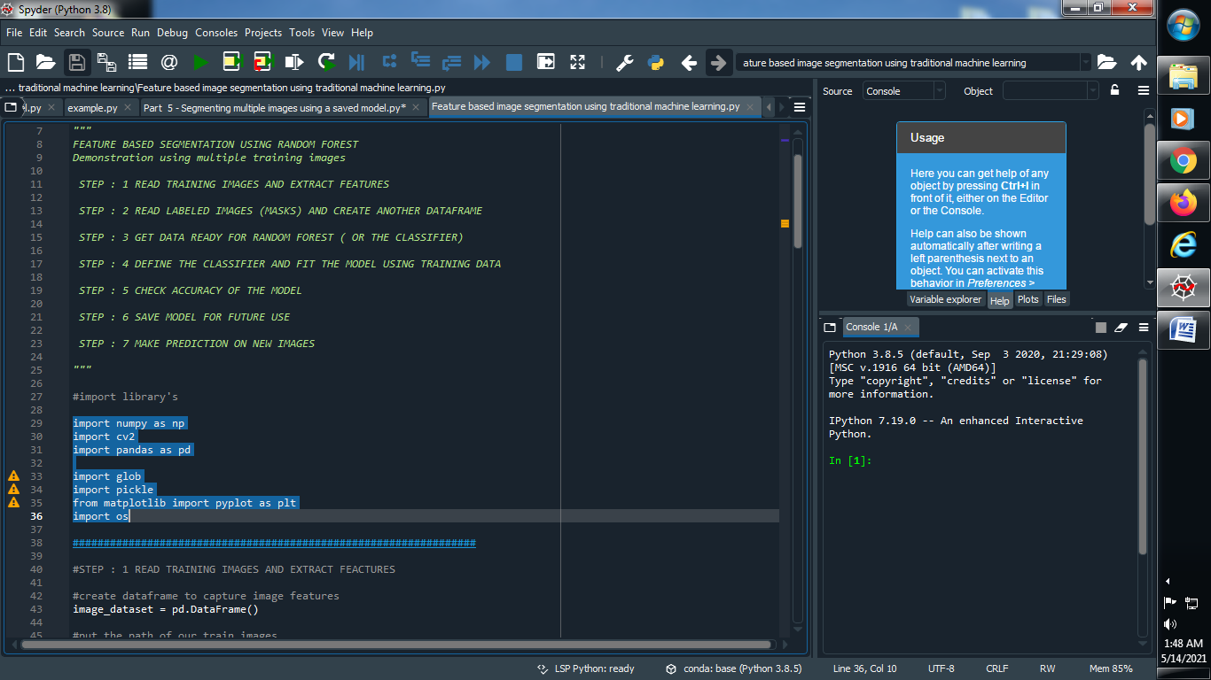

**(3) Create a data frame for capture features and give the path of our trained images :**

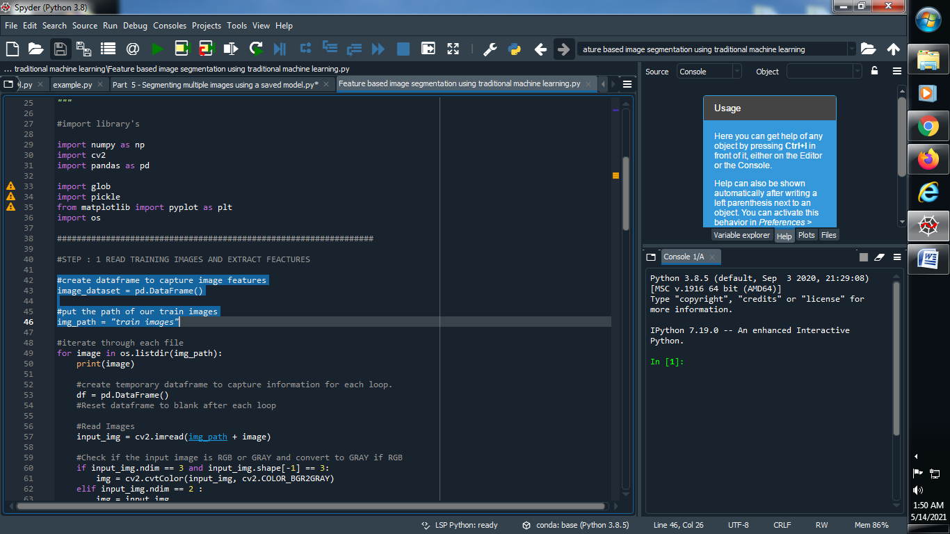

**(4) Create one function so that it iterate through each image :**

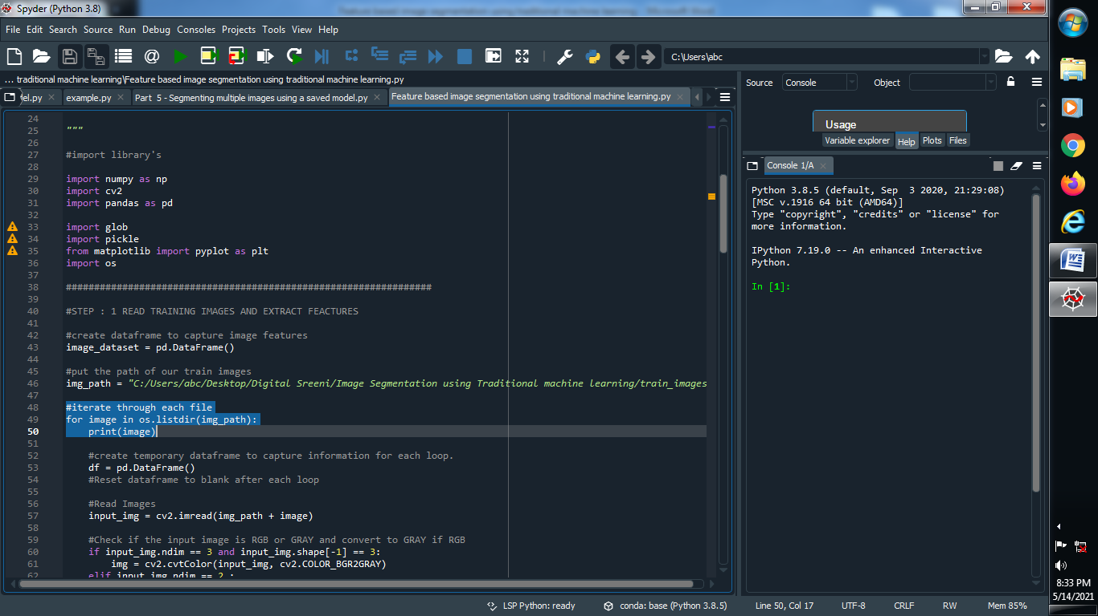

**(5) Create a temporary data frame to capture image through each loop and read that all images :**

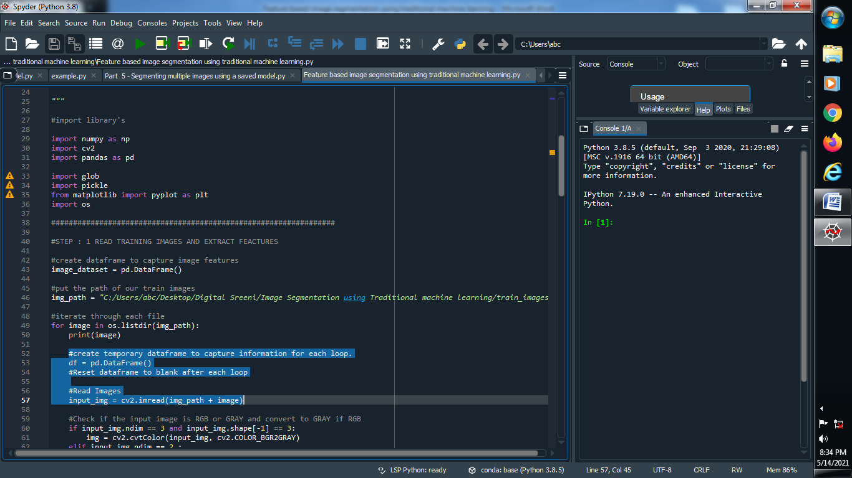

**(6) Check all the images if RGB than convert it onto gray image :**

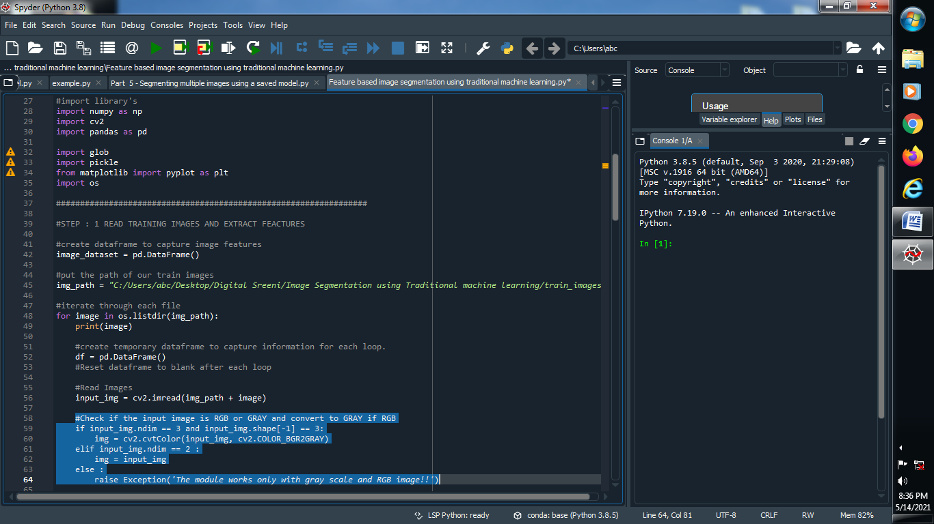

**(7) Start adding data to data frame :**

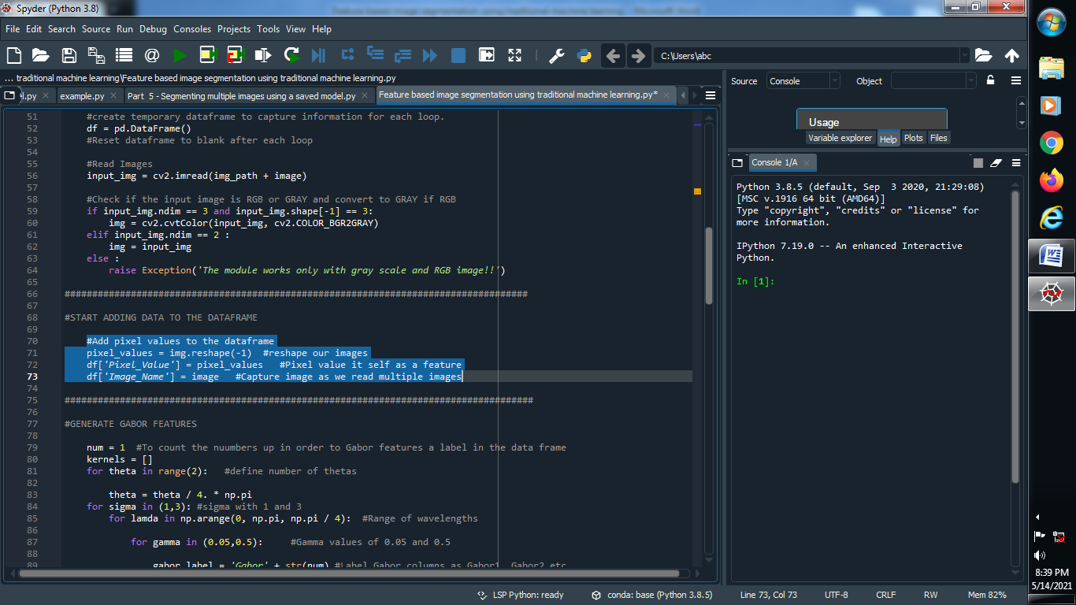

**(8) Apply Gabor Filter :**

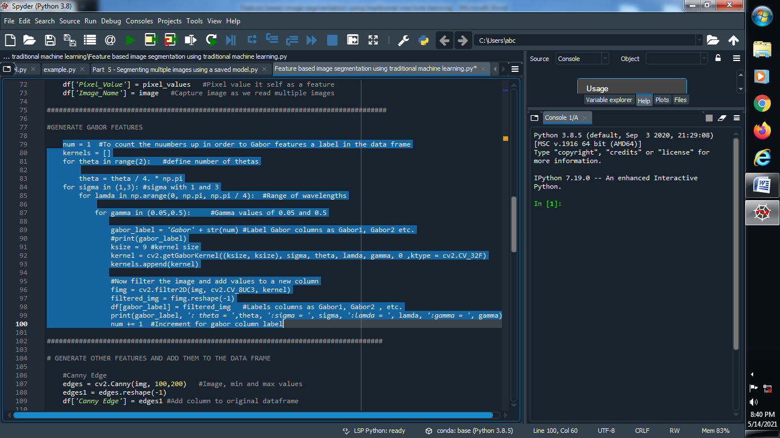

**(9) Apply and generate another filter and add them to the data frame :**

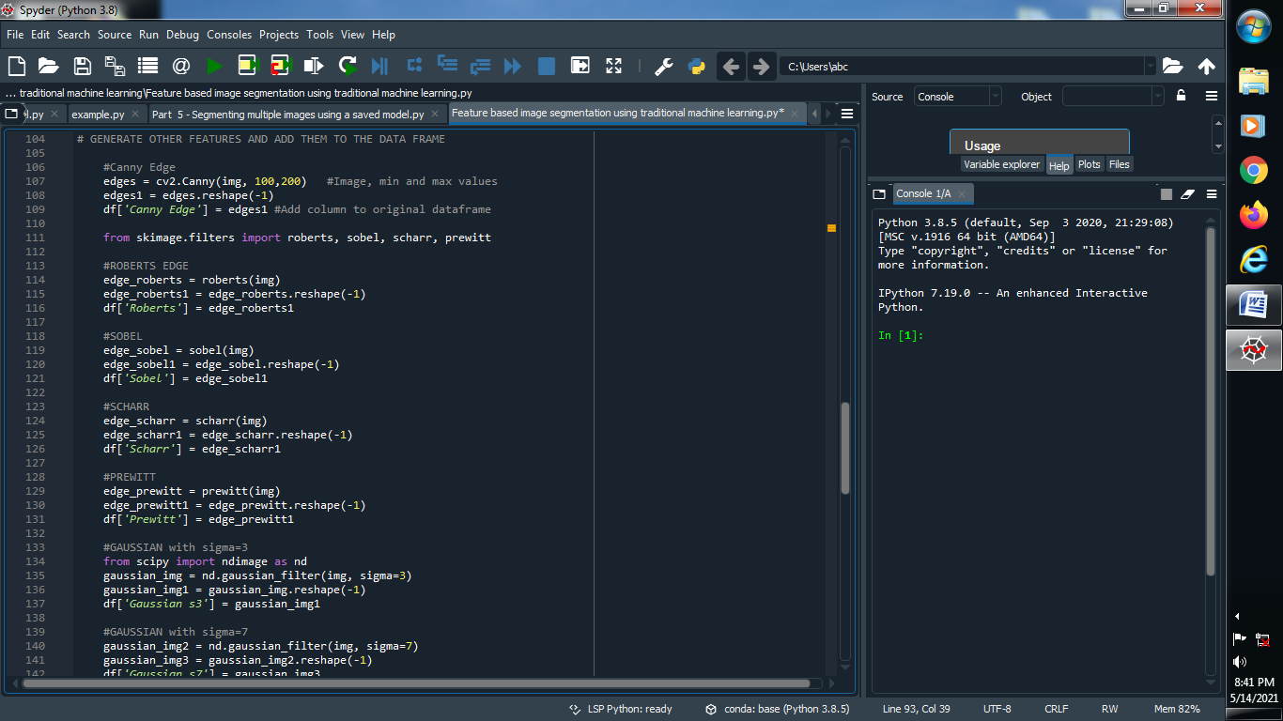

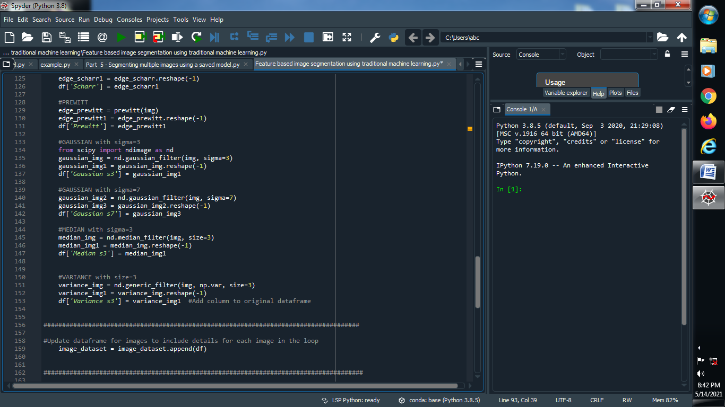

**(10) Update data frame to include images of each loop :**

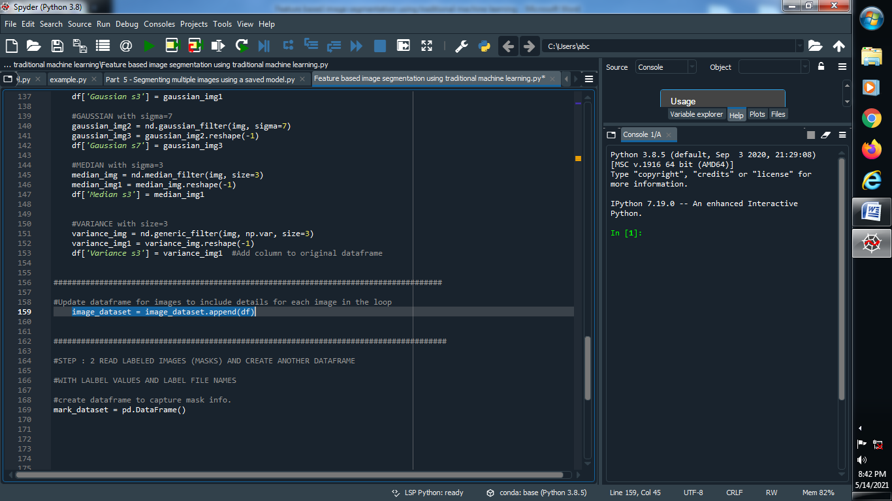

**########################################################################################################################**

**→ STEP : 2 READ LABELED IMAGES AND CREATE ANOTHER DATAFRAME**

**(1) Create a mask data frame and give the path of it :**

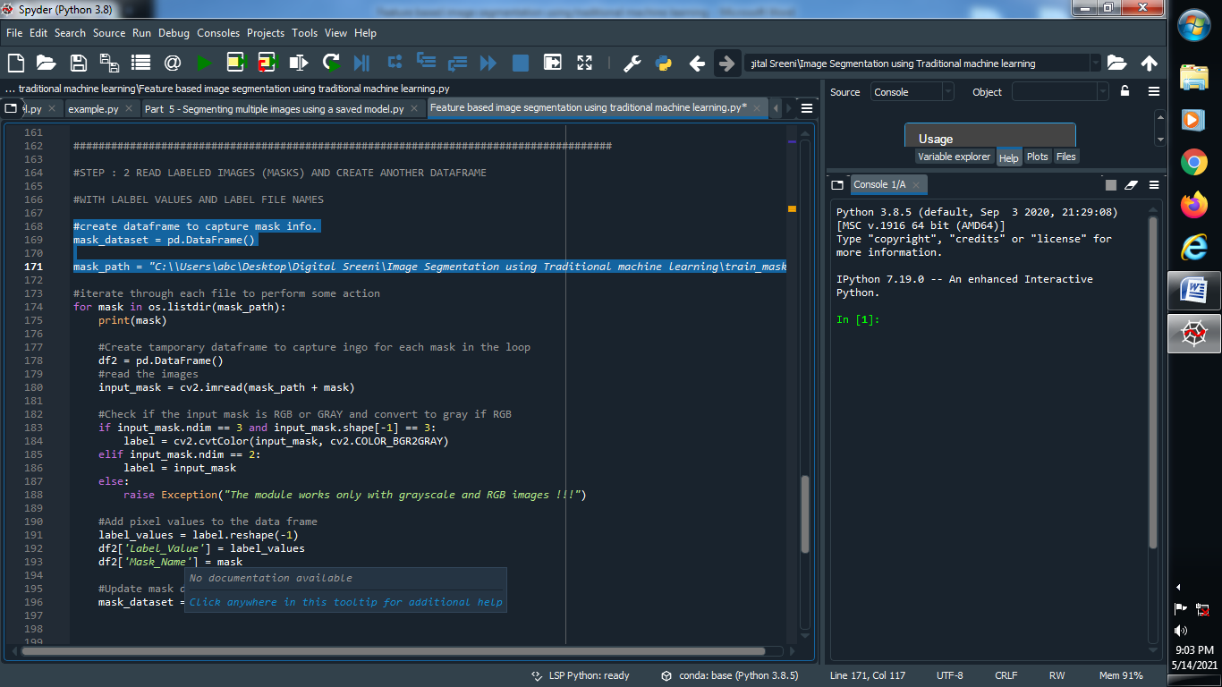

**(2) Create one function for iterate through each images :**

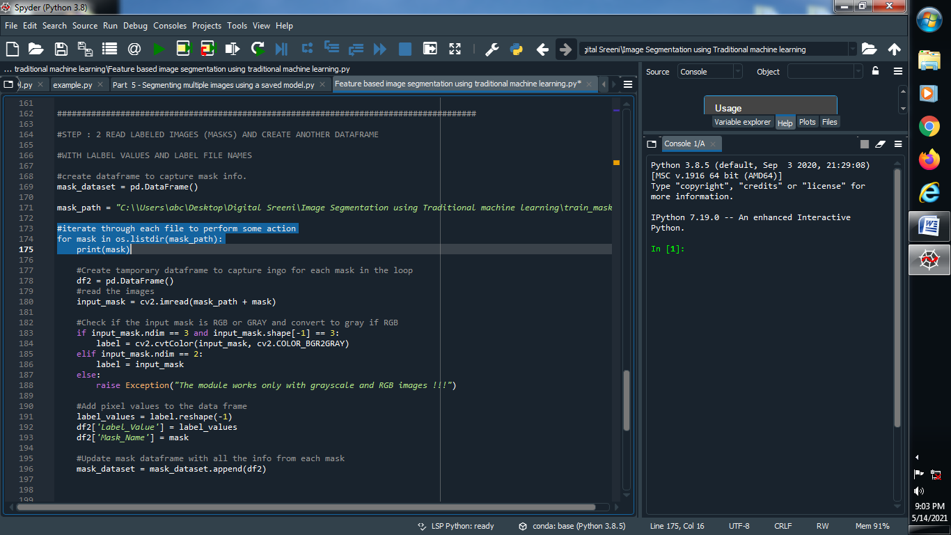

**(3) Create a temporary data frame to capture information of each mask and read that images :**

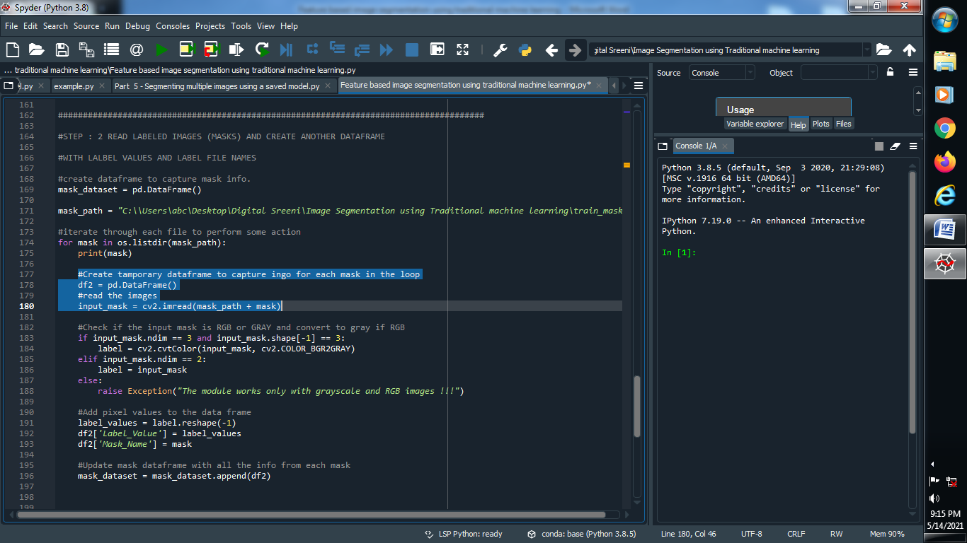

**(4) Check if the mask is RGB or GRAY if RGB than convert it to GRAY :**

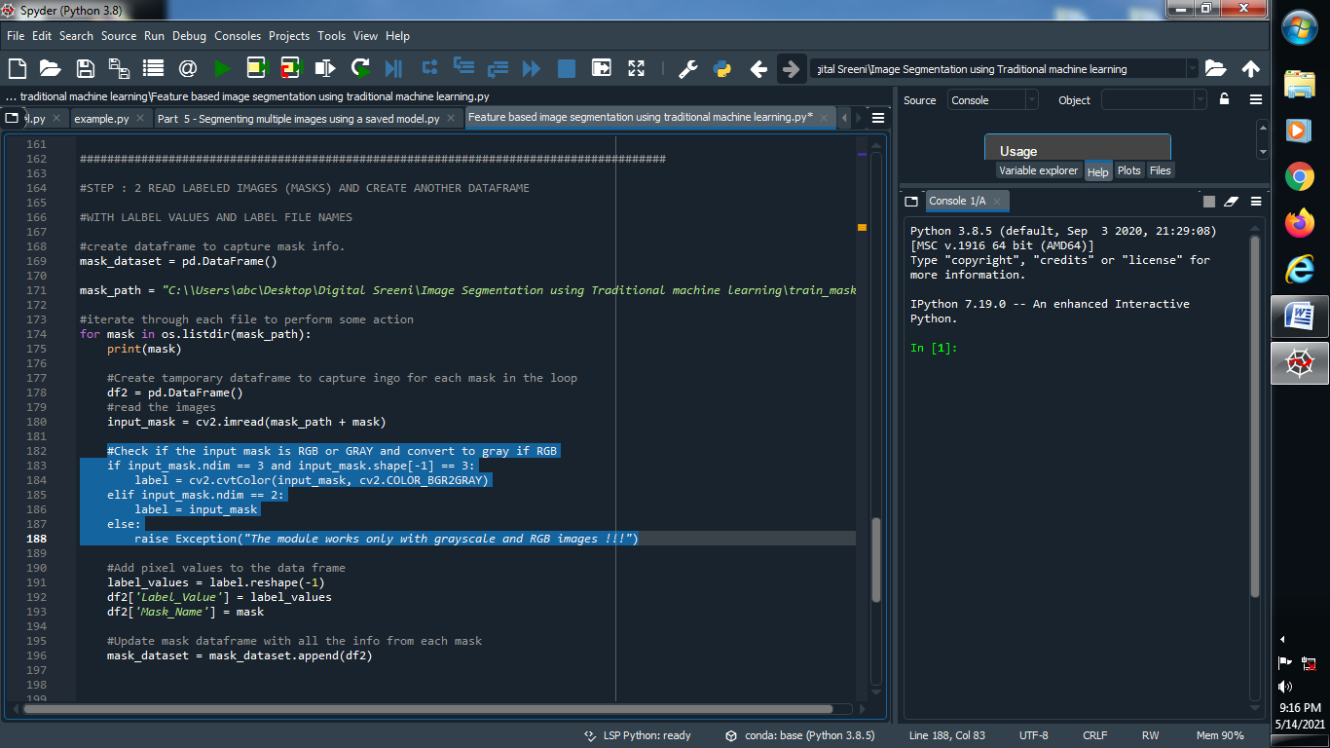

**(5) Add pixels value to the data frame :**

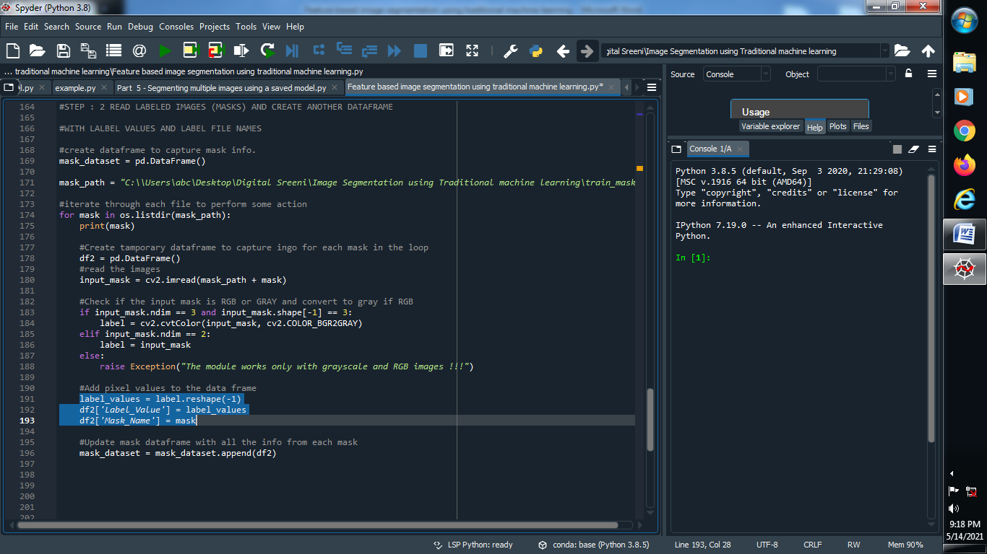

**(6) Update our data frame with all the information with the each mask :**

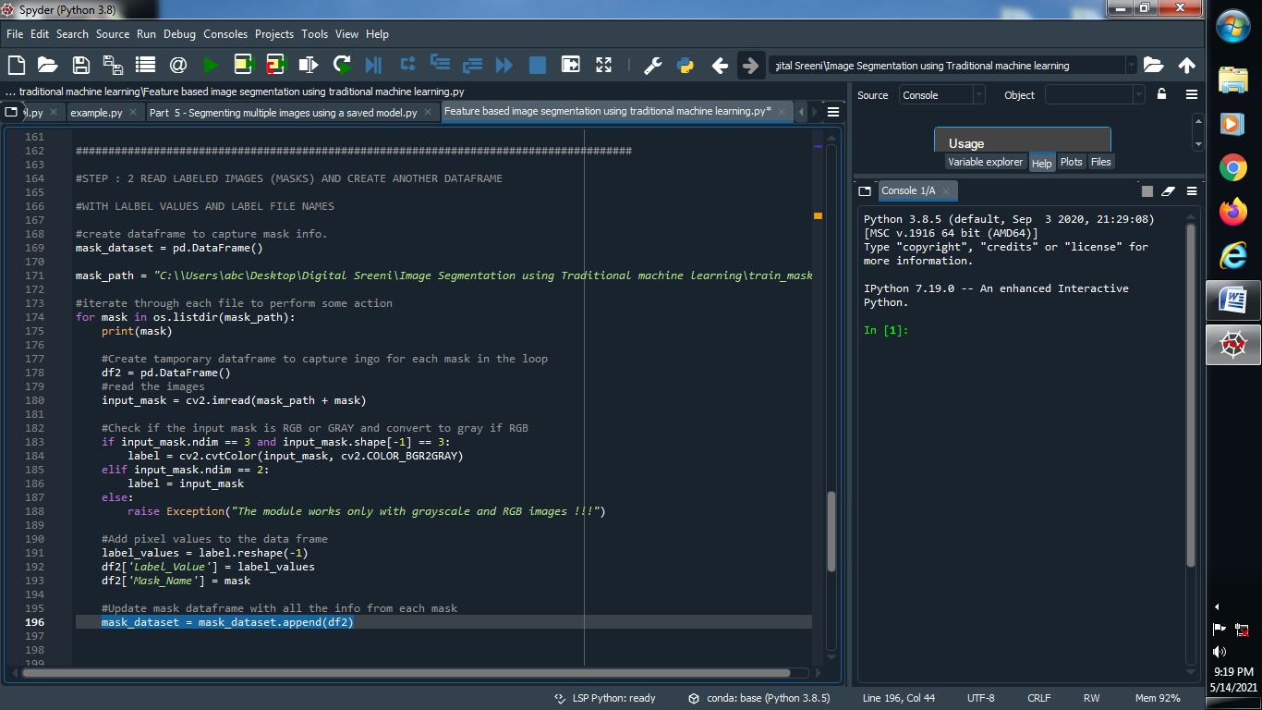

**###################################################################################**

**STEP : 3 GET DATA READY FOR RANDOM FOREST ( OR OTHER CLASSIFIER )**

**(1) Combine both dataset into a single dataset using concatenate method :**

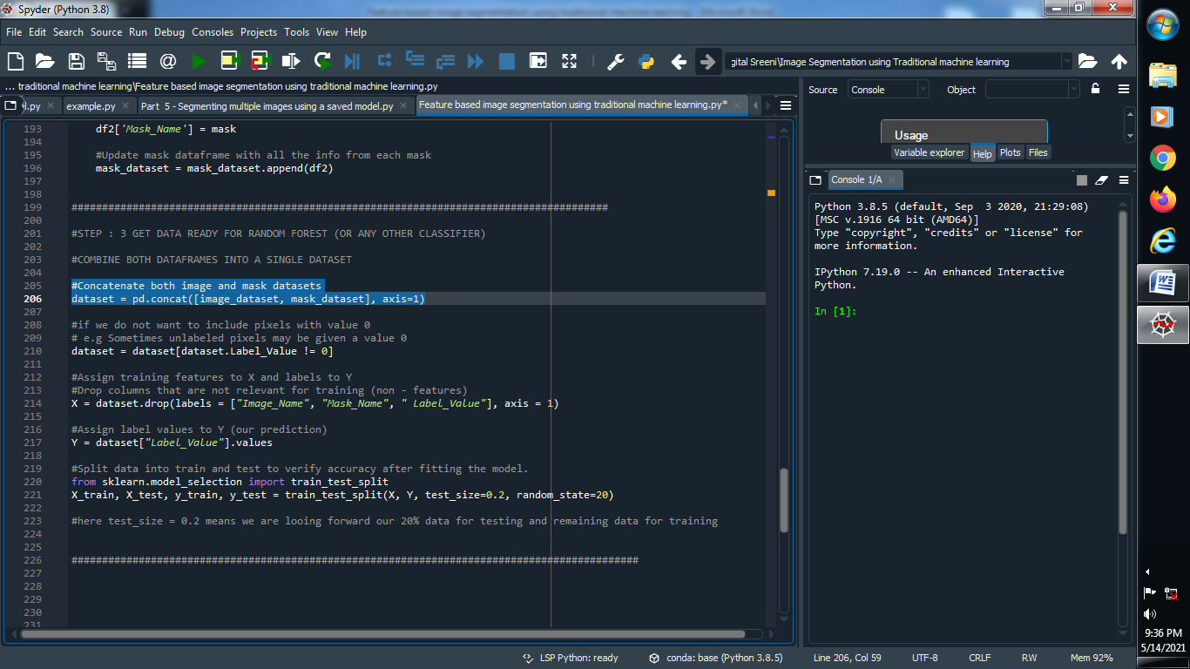

**(2) Delete that pixel values which is 0 :**

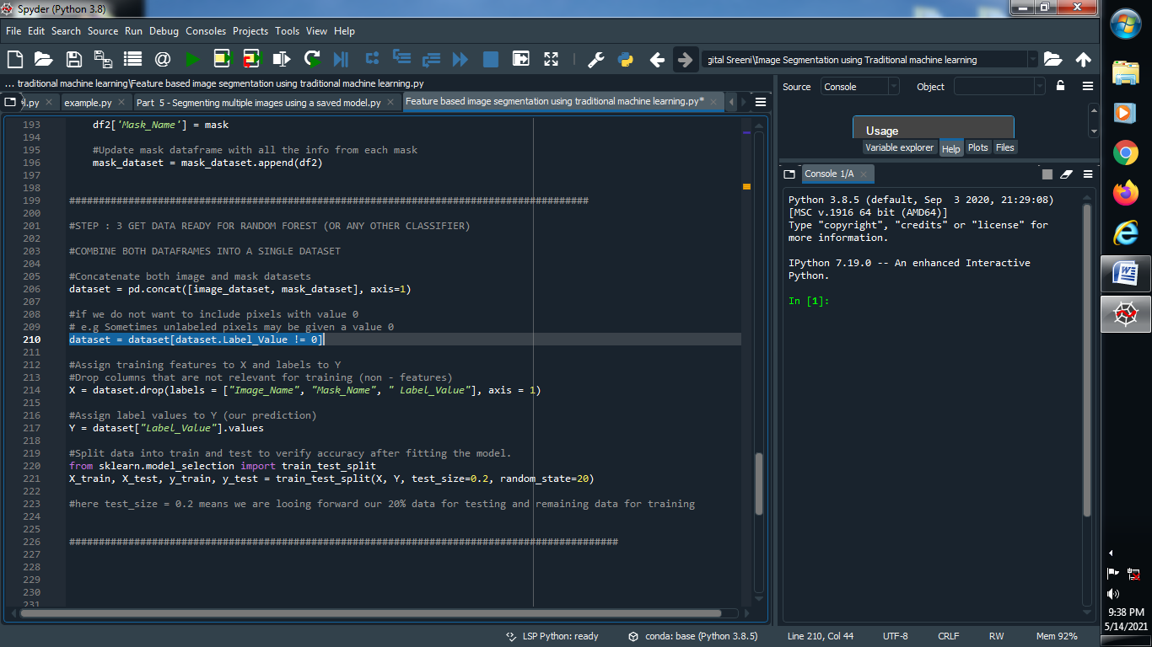

**(3) Assign training features to X and Y and drop the columns that are not relevant data for training :**

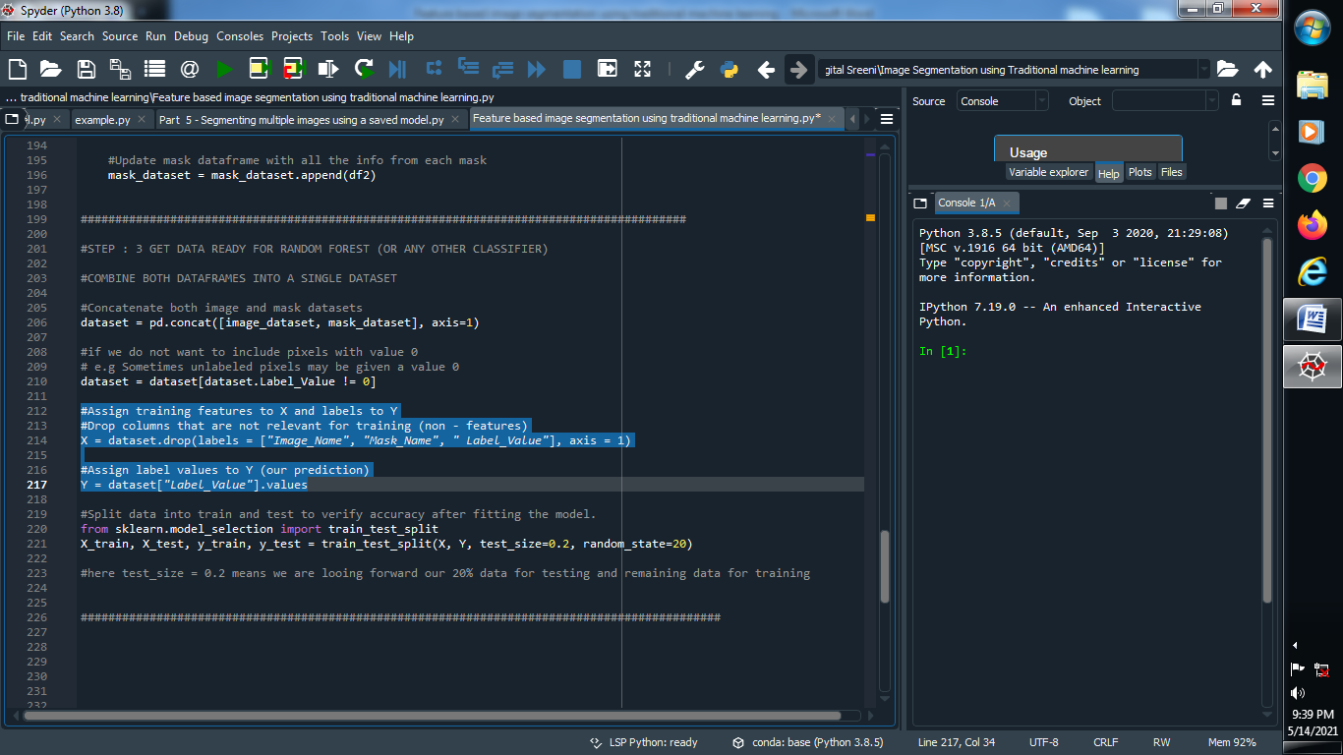

**Note : Always remember that in machine learning our X is allocated for training data and Y is for our Prediction ..**

**(4) Split the data into training and testing to verify accuracy after fit the model :**

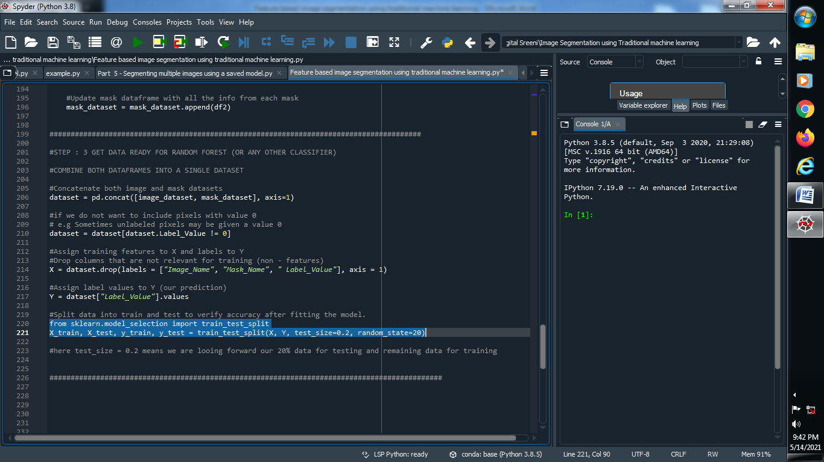

**####################################################################################**

**STEP : 4 DEFINE A CLASSIFIER AND FIT A MODEL WITH OUR TRAINING DATA**

**(1) Import training classifier :**

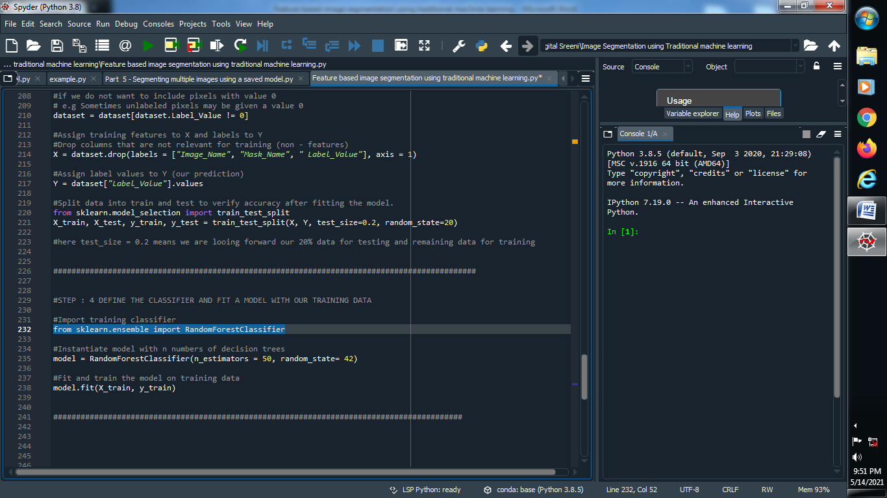

**(2) Create a model and instantiate model with n number of decision trees :**

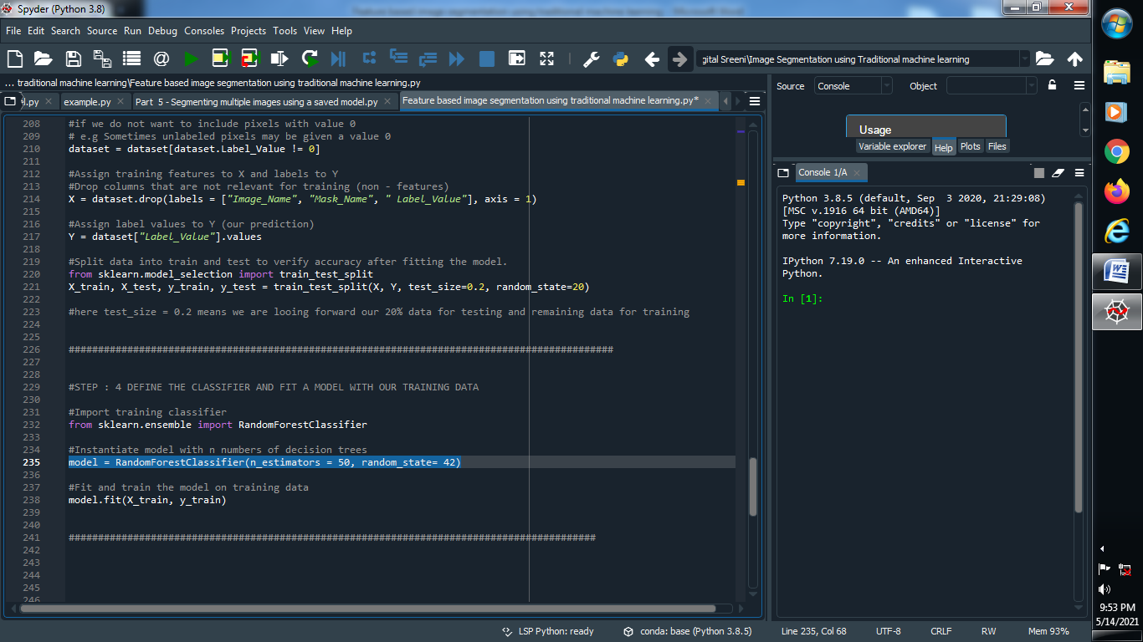

**(3) Fit and train the model on training data :**

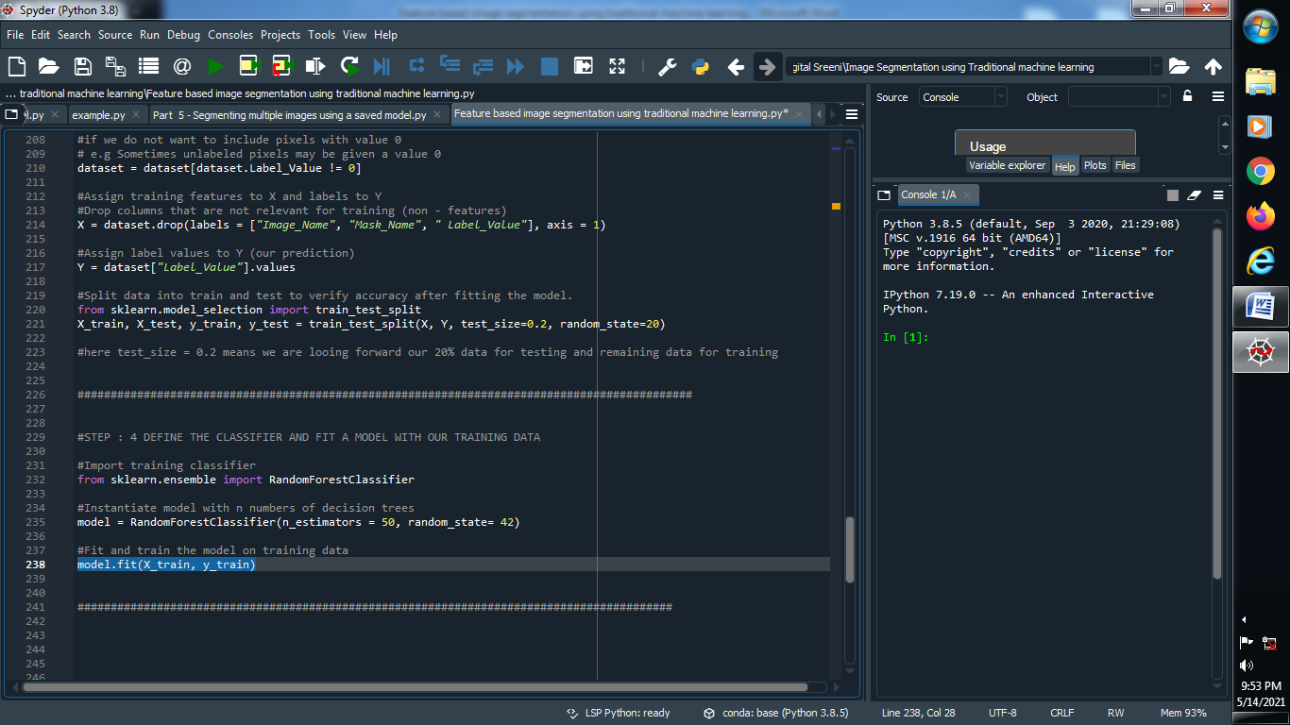

**###############################################################################################**

**STEP : 5 ACCURACY CHECK**

**(1) Predict our test model :**

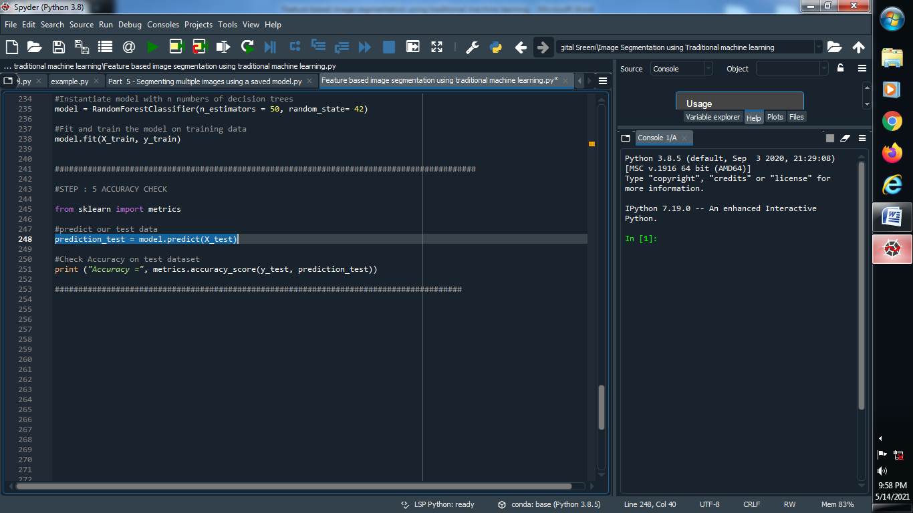

**(2) Check accuracy on test dataset :**

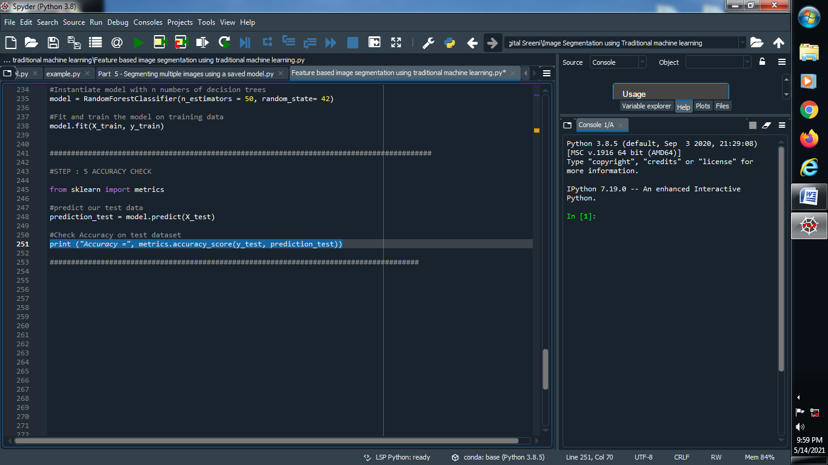

**####################################################################################################**

**STEP : 6 SAVE MODEL FOR FUTURE USE**

**(1) Give the model name :**

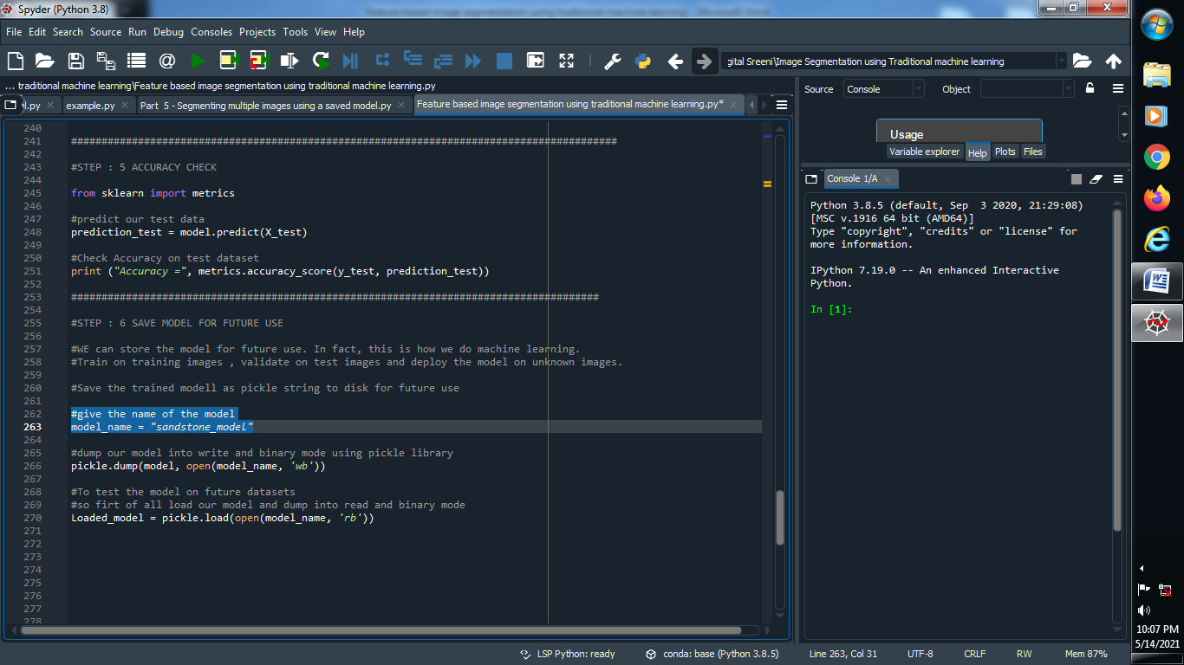

**(2) dump our model into write and binary mode using pickle library :**

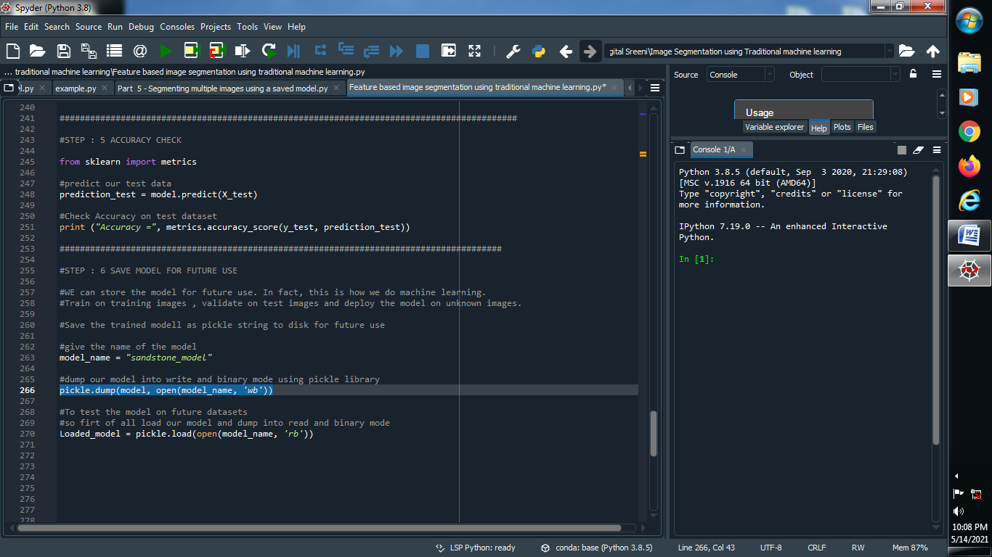

**(3) To test our model on future use so that we load our model**

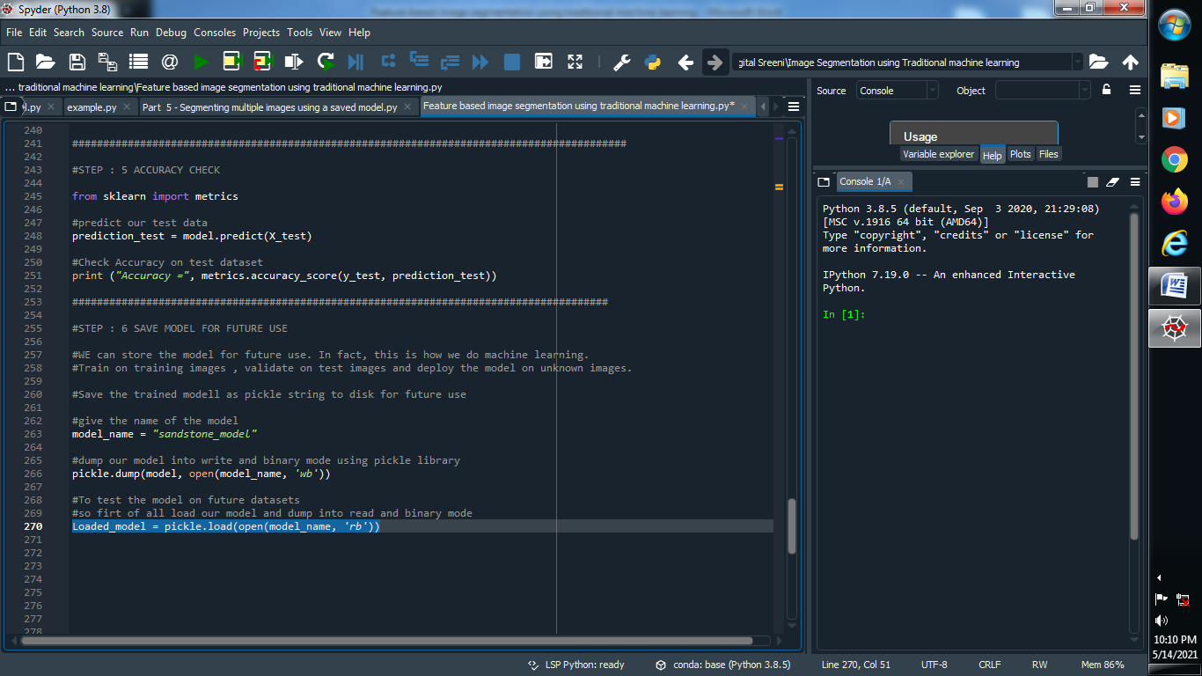

**########################################################################################**

**STEP : 7 MAKE PREDICTION ON NEW IMAGES**

**(1) Define Function and Create data frame**

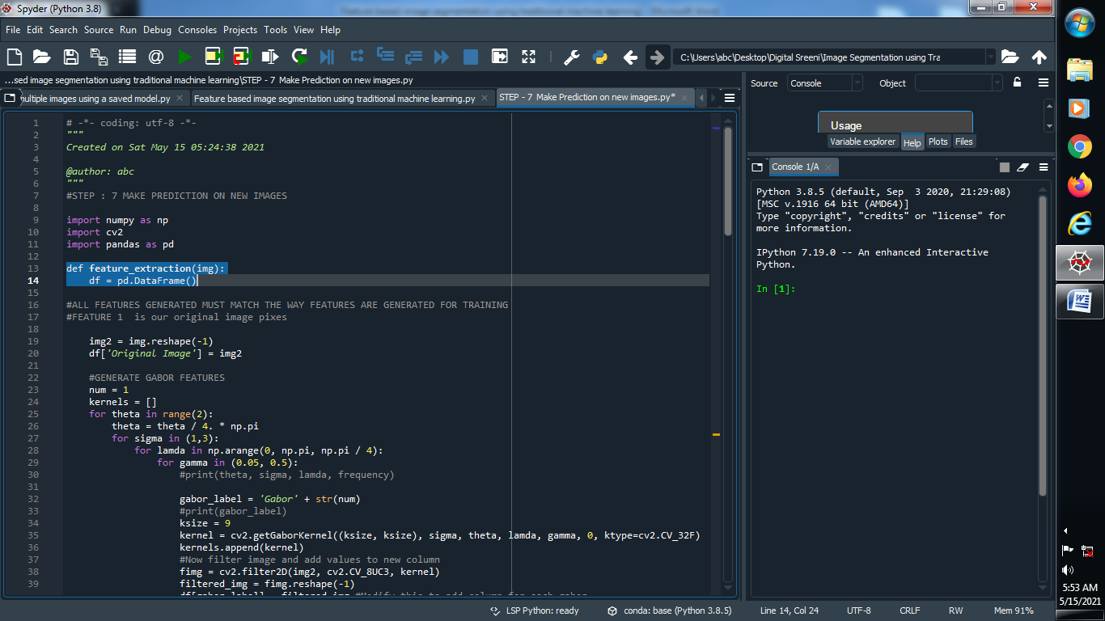

**(2) Reshape our image and add column name to our data frame**

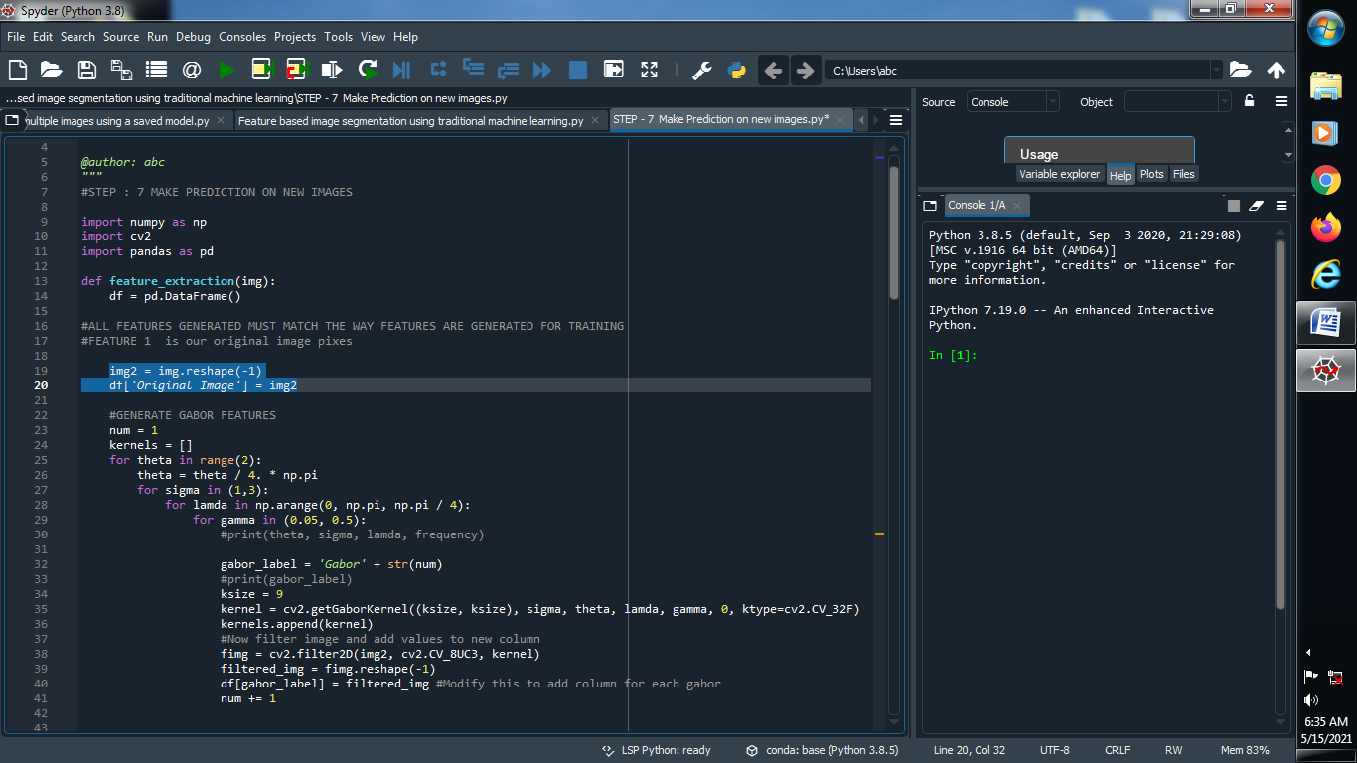

**(3) Generate gabor feature :**

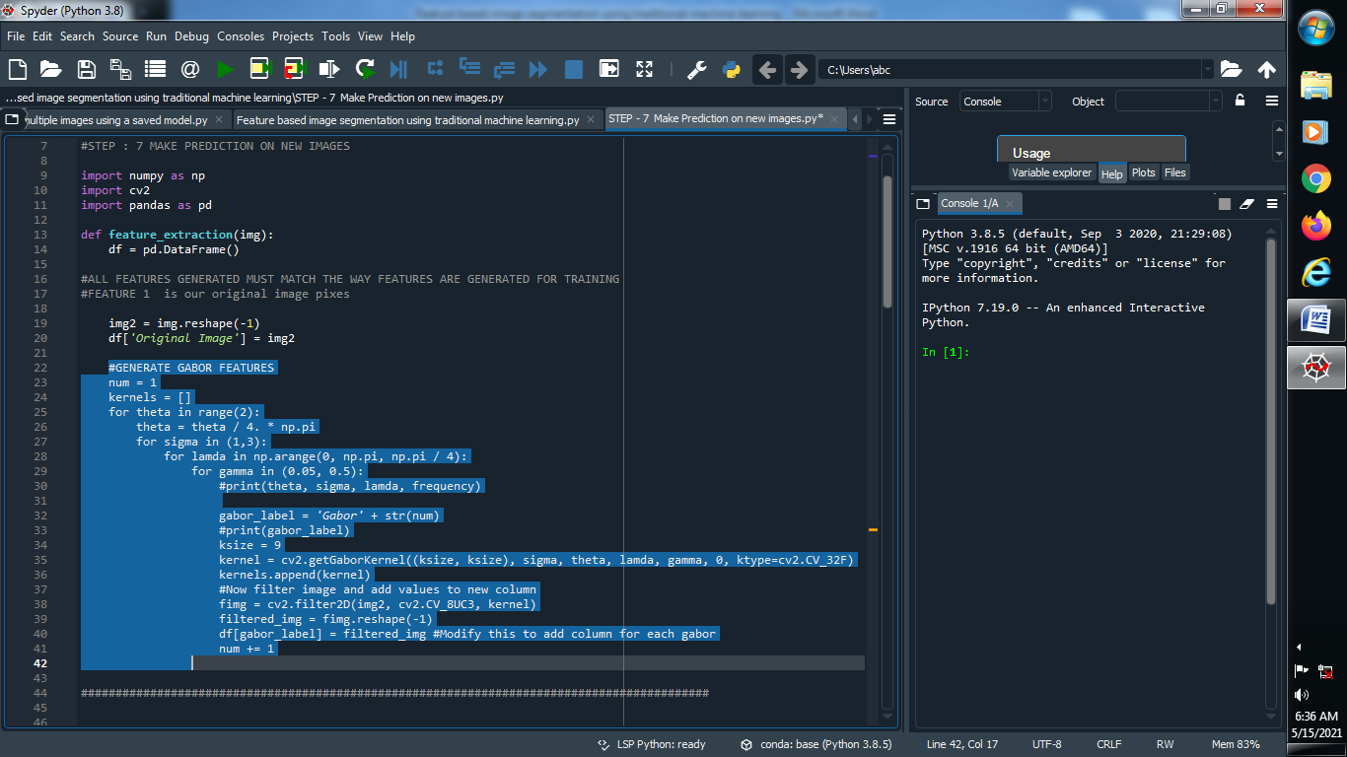

**(4) Generate Canny edge feature :**

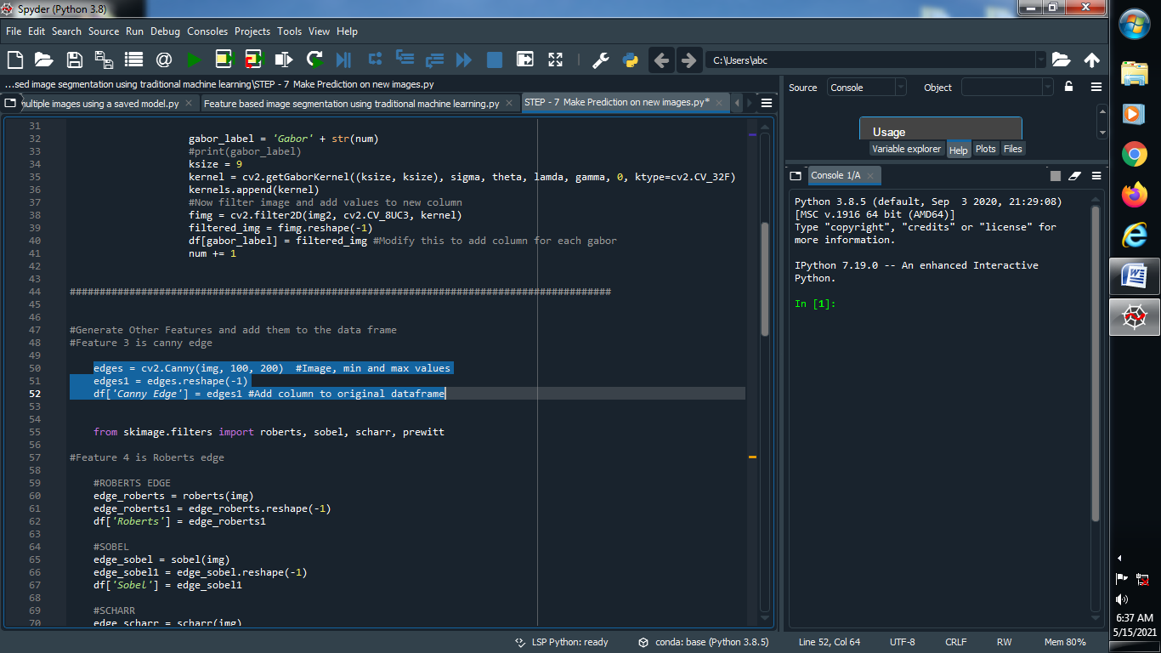

**(5) Add more features :**

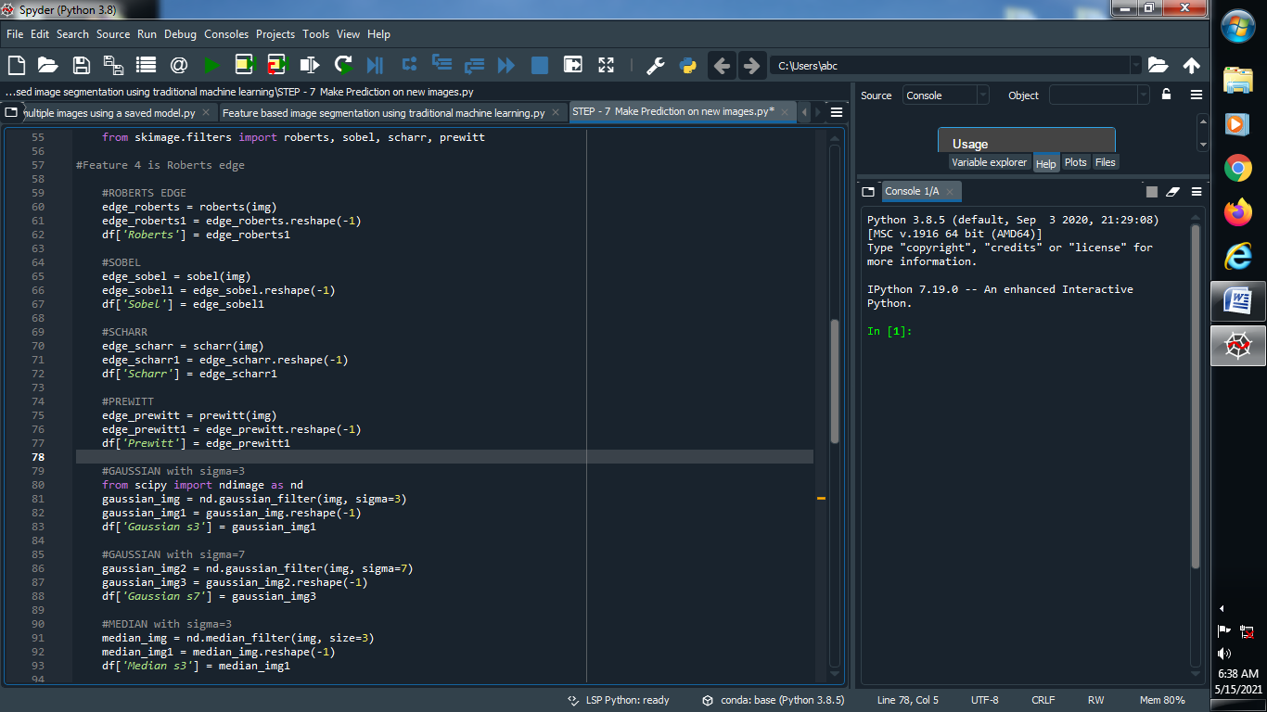

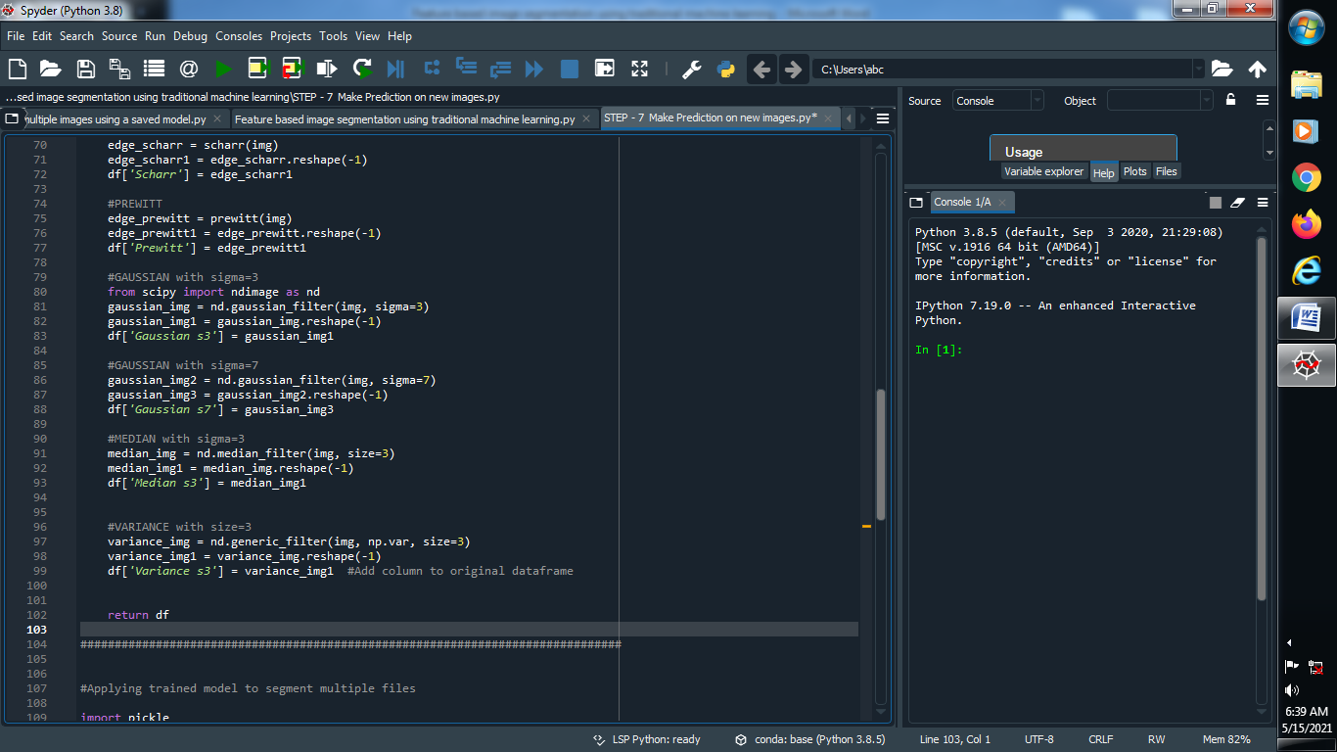

**(6) Applying trained model to segment multiple files :**

